Information on tourist spots around Ojiya

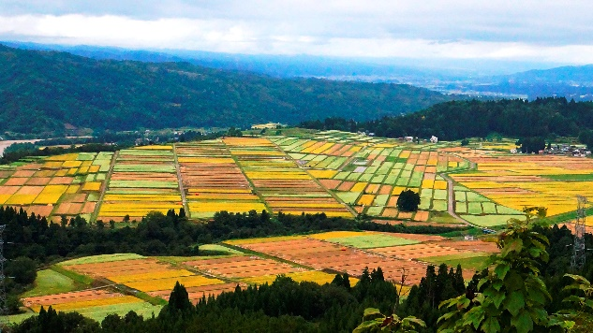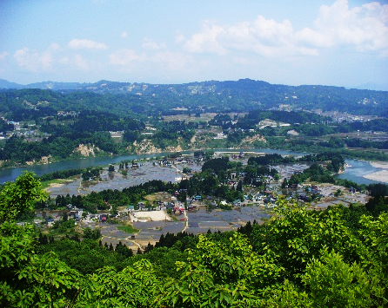
Yamamotoyama(Mt. yamamoto)

Yamamotoyama is a symbol of Ojiya. It is only 336m high but when you go up you can enjoy a wonderful panorama of the city. You can view the three mountains of Echigo, the Shinano river running beautifully through the city, and even the distant mountains in Aizu (Fukushima prefecture). There are more views to see, such as the sea of clouds in early mornings, the rape blossom field in spring, the sunflower field and soba flower in summer, patchwork of rice fields in fall and the sky filled with stars at night. You can also watch raptorial birds glide through the impeccable blue sky.
There is a community center with an exhibition facility of JR East Ojiya Shinano-river Hydroelectric Power Plant called “Oja~ru” halfway up the mountain. At the exhibition, you can learn how the power plant generates electricity for trains and Shinkansen ‘Bullet Train’ of JR East (East Japan Railway Company).
The community center is used for corporate training camps and many local events. There’s more to it! You can run around the broad grass park, play sports with your friends or relax with your family. That’s not all! You can enjoy BBQ under the beautiful sun. Don’t forget your dog (if you have one)! There’s a dog park for them to run around in the nice weather and make new buddies. Want to stay overnight? Sure thing! You can camp in the field and get amazed by the glamorous sky filled with stars, so many of them that it will make you feel like you're in space. OR... you have the option to stay at the community center which is full of amenities. Don’t have the gears? No worries. You can rent tools and gears for BBQ and camping. You can even buy foods and beverages. Some of these stuff needs to be reserved in advance so check out their website for more information!
( https://www.ojiya-r.com/index.html Currently they only have a Japanese website so have someone help you if you are interested.)

